Lab 4 – Vaibhav Sandhir

Q1.)
Server Program :

import socket

HOST = '127.0.0.1'
PORT = 12345

s = socket.socket(socket.AF_INET, socket.SOCK_STREAM, 0)
s.bind((HOST, PORT))
s.listen()

conn, addr = s.accept()
data = conn.recv(1024)
print('Received ' + data.decode() + ' at server')
conn.sendall(data)

conn.close()

Client Program :
import socket

HOST = '127.0.0.1'
PORT = 12345

s = socket.socket(socket.AF_INET,socket.SOCK_STREAM);
s.connect((HOST, PORT))

message = input('Enter message to send to server: ')
s.sendall(message.encode())

data = s.recv(1024)
print('Received ' + data.decode() + ' at client')
s.close()

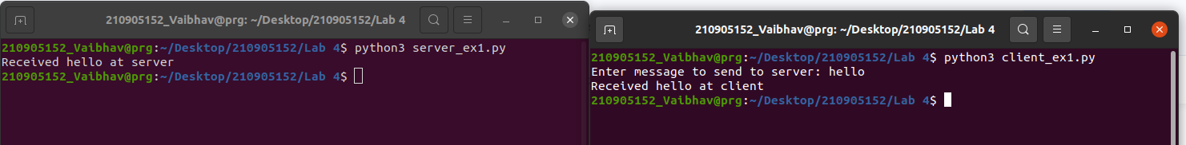
Q2.)

Server Program :

import socket
import time

host = socket.gethostname()
port = 9991

s = socket.socket(socket.AF_INET, socket.SOCK_STREAM)

s.bind((host, port))
s.listen(5)

while True:
conn, addr = s.accept()
print("Connection from " + str(addr))
currentTime = time.ctime(time.time()) + "\r\n"
conn.send(currentTime.encode('ascii'))
conn.close()

s.close()
Client Program :

import socket

host = socket.gethostname()
port = 9991
s = socket.socket(socket.AF_INET, socket.SOCK_STREAM)
s.connect((host, port))

time = s.recv(1024)
print('Current time from server : ' + time.decode())
s.close()
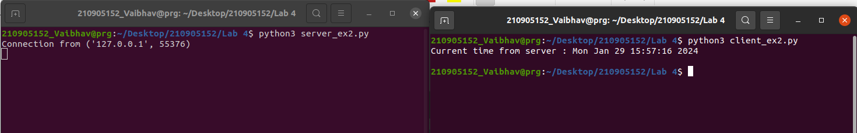
Q3.)
Server Program :

import socket

host = socket.gethostname()
port = 31621
s = socket.socket(socket.AF_INET, socket.SOCK_STREAM)

s.bind((host, port))
s.listen(5)

conn, addr = s.accept()

s_name = conn.recv(1024)
s_name = s_name.decode()
print(s_name + ' has entered the chat room\n Enter [e] to exit\n')
name = input("Enter your name : ")
conn.send(name.encode())

while True:
message = input("Me : ")
if message == "e":
message = "Left Chat Room"
conn.send(message.encode())
break
conn.send(message.encode())
message = conn.recv(1024)
message = message.decode()
print(s_name + ":" + message);

Client Program :

import socket

host = socket.gethostname()
port = 31621
s = socket.socket(socket.AF_INET, socket.SOCK_STREAM)
s.connect((host, port))

name = input("Enter your name : ")
s.sendall(name.encode())
s_name = s.recv(1024)
s_name = s_name.decode()
print(s_name + ' has entered the chat room\n Enter [e] to exit\n')

while True:
message = s.recv(1024)
message = message.decode()
print(s_name + ": " + message);
message = input("Me: ")
if message == "e":
message = "Left Chat Room!"
s.send(message.encode())
break
s.send(message.encode())

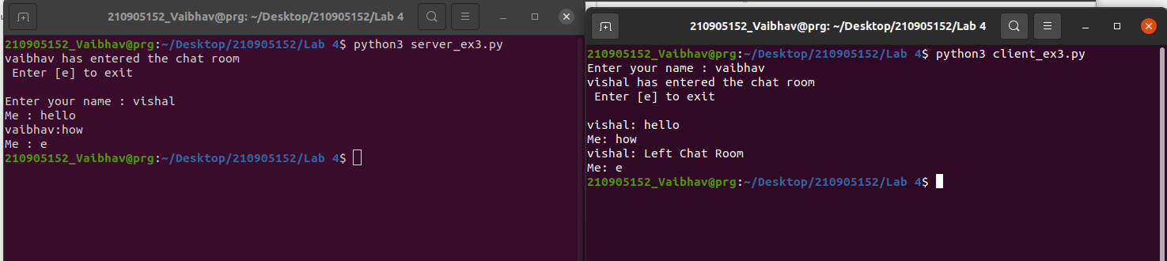
Q4.)
Server Program :

import socket
import os
from _thread import *

threadCount = 0
host = socket.gethostname()
port = 11597
s = socket.socket(socket.AF_INET, socket.SOCK_STREAM)
s.bind((host, port))
s.listen(3)

def threaded_client(connection):
connection.send(str.encode("Welcome to the server"))
data = connection.recv(2048)
print("Received from client:" + str(threadCount) + data.decode())
msg = input("Server says : ")
connection.sendall(msg.encode())
connection.close()

while True:
conn, addr = s.accept()
start_new_thread(threaded_client, (conn, ))
threadCount += 1

s.close()

Client Program :
import socket

host = socket.gethostname()
port = 11597
s = socket.socket(socket.AF_INET, socket.SOCK_STREAM)
s.connect((host, port))

msg = s.recv(1024)
print(msg)

while True:
msg = input('Client : ')
s.send(msg.encode())
resp = s.recv(1024)
print('From Server : ' + resp.decode())

s.close()

